

Project 1: Simply Blogging

Name: Ahmad Mohammed Najjar

Username: [ahmadnajjar1420@gmail.com](mailto:ahmadnajjar1420@gmail.com)

Report

The Steps Below is how I made the website:

Step1: What I used on this project…

Visual studio code: as the main text editor for coding

Bootstrap: for the main design of this project

Html/CSS: the core of this project

Git/GitHub: for the resource code

JavaScript: programming language

Step2: details of this project as follows.

First: creating the Directory to start the project



Second: create the files for the project

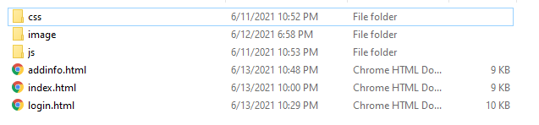

Third: put bootstrap files on the css and js directory

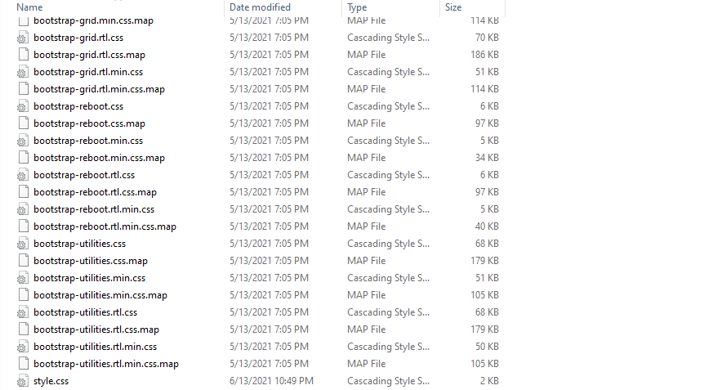

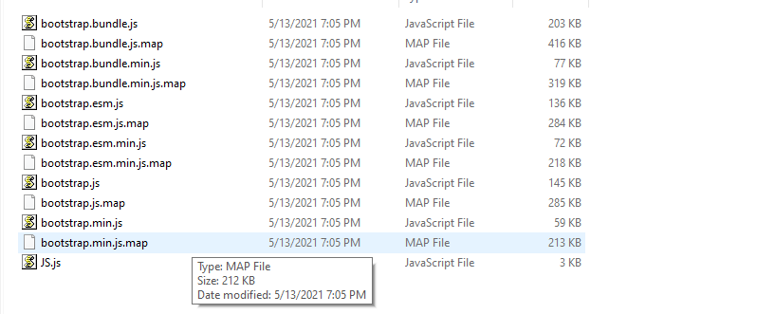

Note: all of this was made by git bash on the vscode

Except the bootstrap files and put them on the local repository 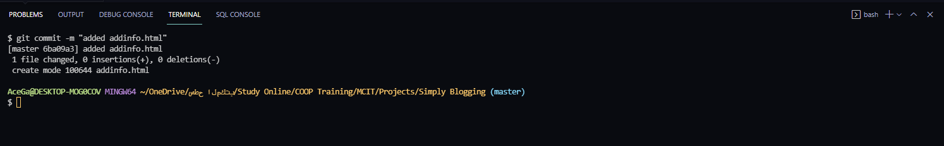

Step3: the index.html design

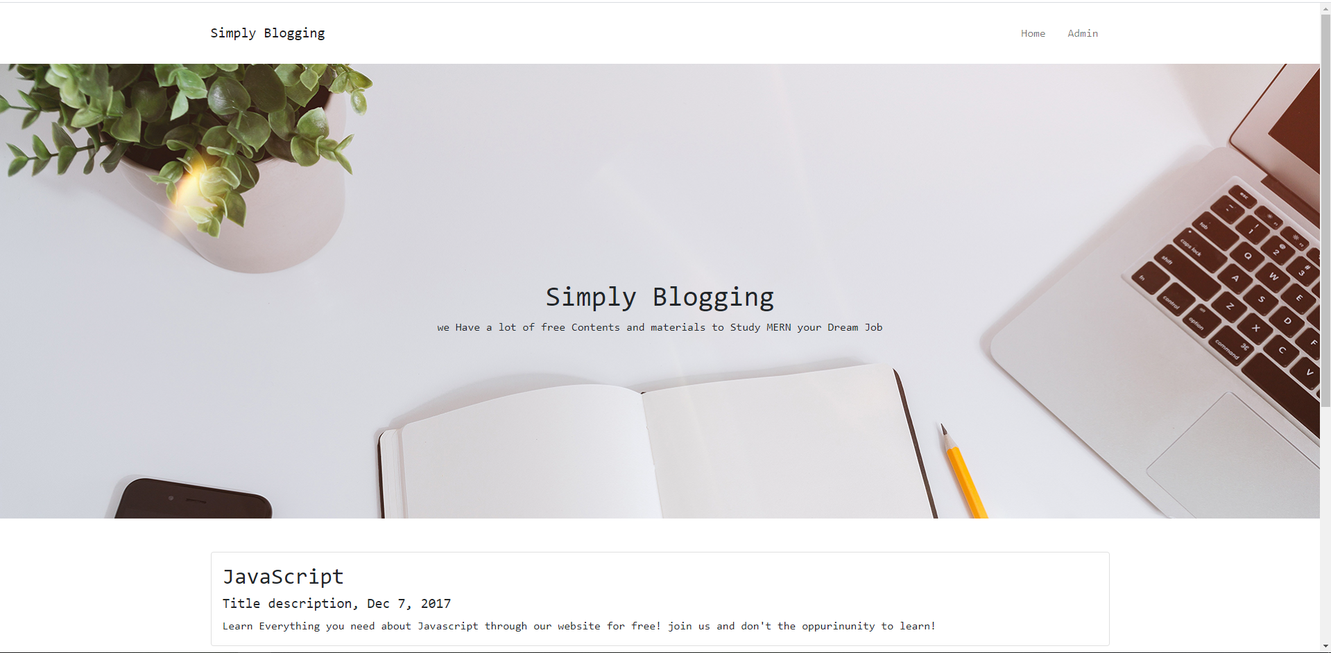

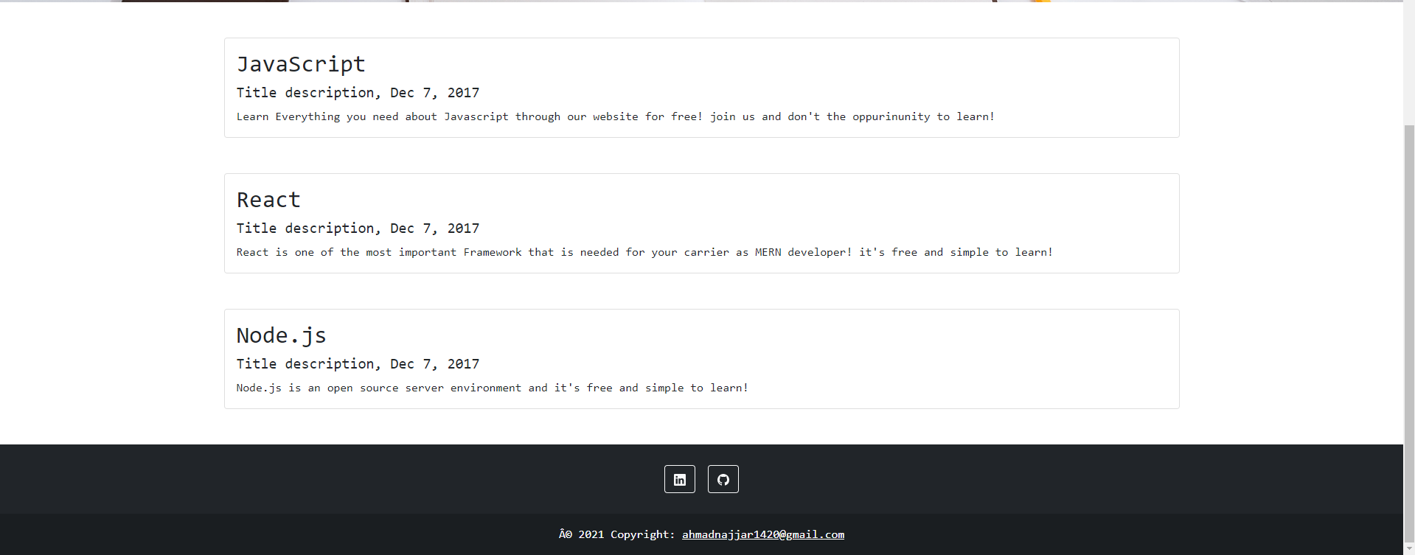

For the navbar and footer I used the same one that found on Bootstrap 5 .com with changing some details

Using bootstrap and CSS

For the header and section I used a bootstrap from other website guides

Step4: the login.html design

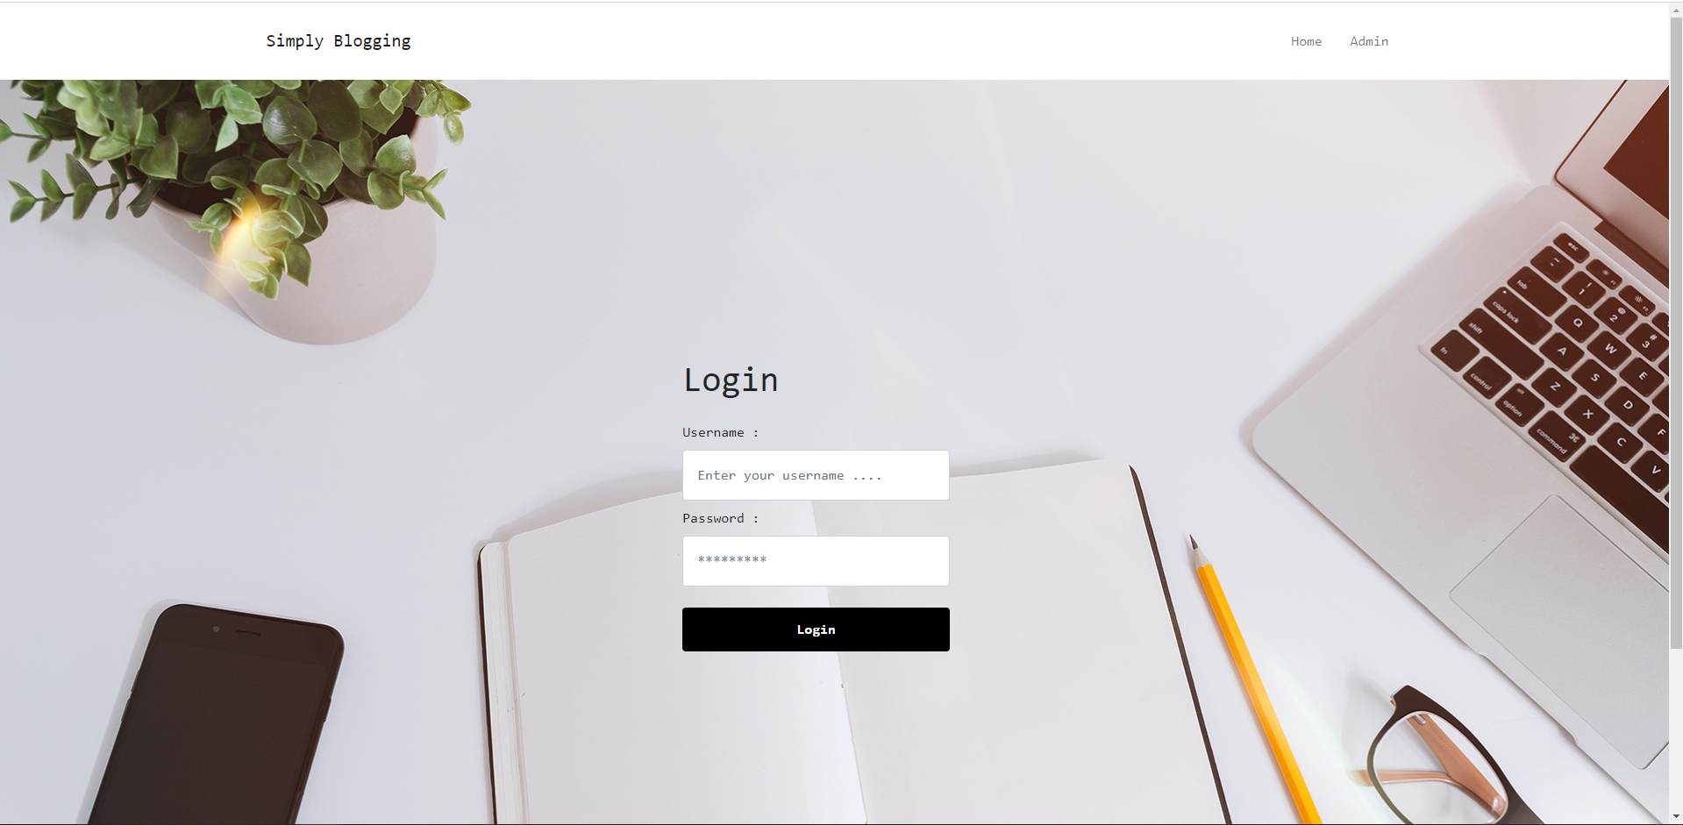

Here I used the same navbar and footer but the header I changed it and made the background/photo bigger and put the login form inside it using bootstrap and CSS

For the validation of the login it is as follows…

-null

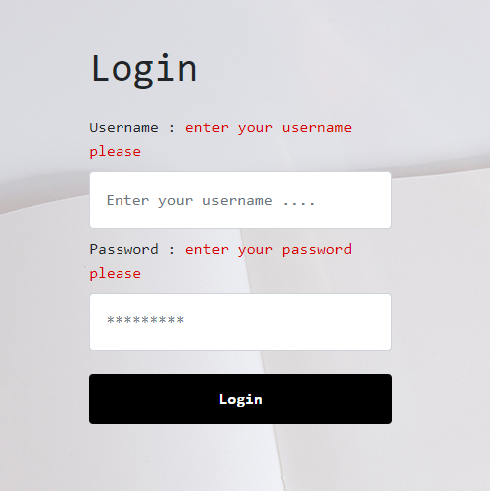

-a wrong pass or username

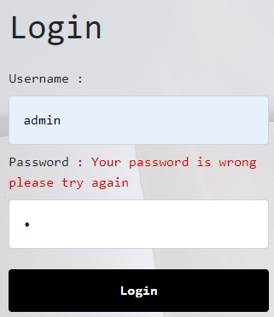 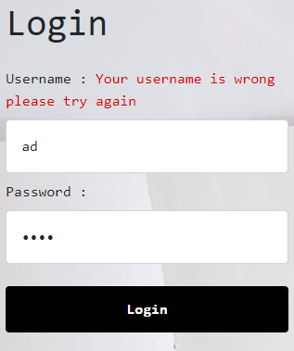

When we press on login it will direct us to the addinfo.html

Step5: the addinfo.html design

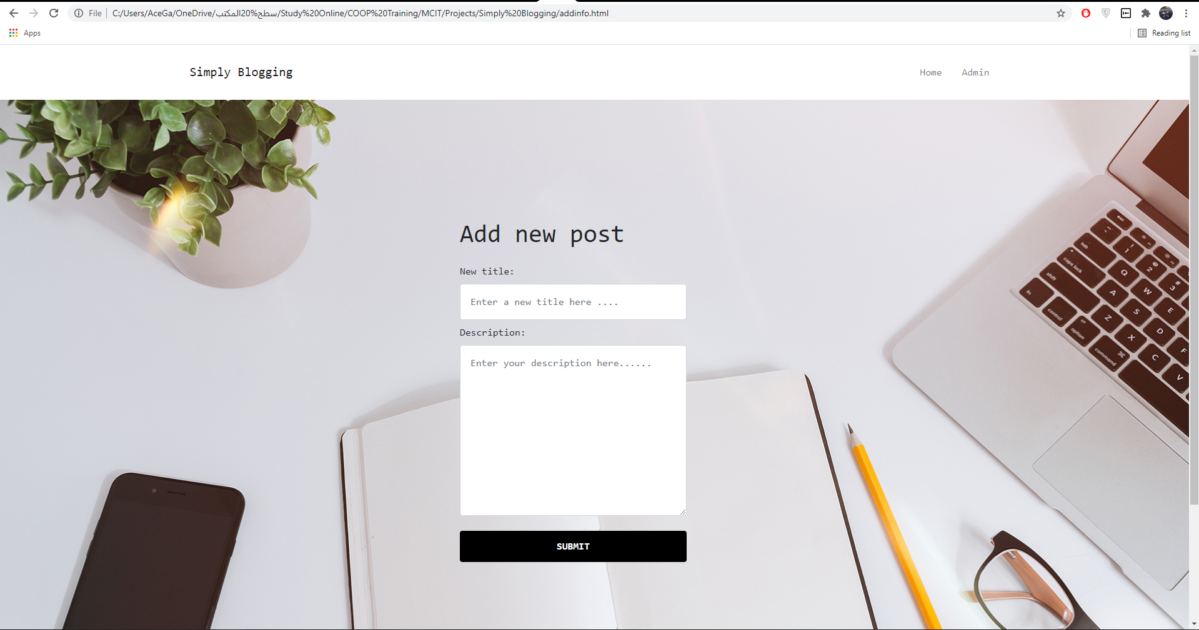

Here is the admin/manage post for the admin to add post To the homepage/index.html, the design is the same as the login page but with changing the form

Step6: add new post to the home page(failed)

I tried to to transfer the data from the addinfo to the home page but it’s not working I don’t know what I did wrong so I just used filled blog with 3 titles and desc

Step7: push the project to the GitHub using git

